



Haredi Kollel Students

Is It Worthwhile for

* Dr. Hila Axelrad is a senior researcher at the Aaron Institute for Economic Policy, Reichman University, and Head of The Center for Economic Policy of the Haredi Society. Tom Sadeh is a researcher at the Aaron Institute for Economic Policy.

Hila Axelrad and Tom Sadeh*

To Join the Labor Market?

This is a short summary, for the full paper (in Hebrew) see

<https://www.runi.ac.il/research-institutes/economics/aiep/policy-papers>

Policy Paper 2024.03 / June 2024

The Aaron Institute’s policy papers series is a product of research and policy suggestions commissioned by the institute and approved for publication by the scientific committee. The views expressed in these papers are those of the authors, and the board takes no responsibility for the suggested policy.

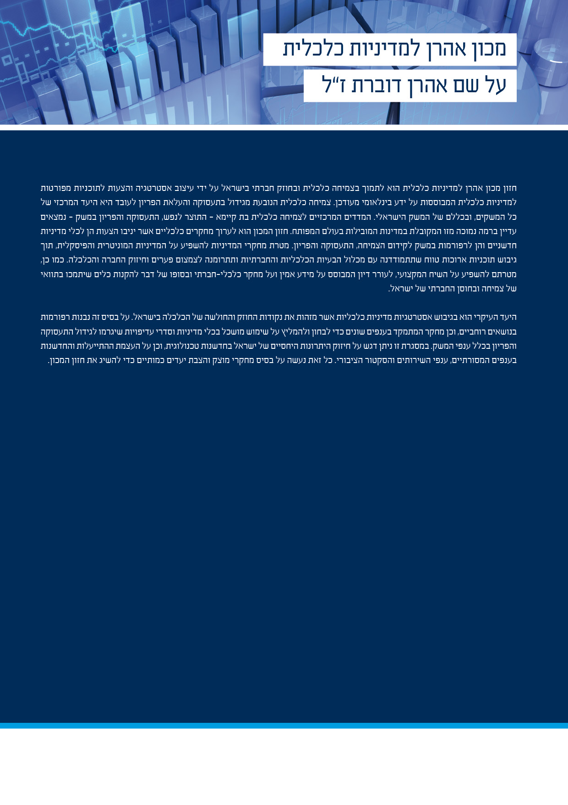

Aaron Institute for Economic Policy

Dedicated to the memory of Aaron Dovrat

The vision of the Aaron Institute for Economic Policy in the Tiomkin School of Economics is to support sustainable economic growth and social resilience, along with poverty reduction. To achieve these goals, the institution strives to design a strategy based on measurable goals, which can be subjected to international comparison, and propose detailed plans for economic policies based on the most updated international knowledge. We focus primarily on reforms towards economic growth stemming from increasing employment and raising the GDP per hour worked (labor productivity) in Israel.

The key measure of sustainable economic growth – GDP per capita – is still low in Israel compared to leading developed countries, and so is labor productivity. Through its economic studies, the Aaron Institute presents goals, innovative policy tools, and reforms to promote growth, high-quality employment, and labor productivity.

The Institute’s mission is to help shaping the socioeconomic policy in Israel through the development of long-term plans that address the full range of economic and social issues facing the Israeli economy. Our main focus is families with less than median income, who comprise significant parts of the Arab and Haredi (ultra-Orthodox) populations. In these groups specifically, increasing employment and productivity would greatly contribute to achieving the goals of growth, social resilience, and poverty reduction. In addition, our studies aim to influence the professional discourse, and to stimulate discussion based on reliable information and socioeconomic research that offers practical tools to achieve these goals.

 **Board Members:**

Mr. Shlomo Dovrat (Chairman), Mr. Jaron Lotan (Vice Chairman), Ms. Yael Andorn, Mr. Yarom Ariav, Mr. Gabi Ashkenazi, Ms. Dita Bronizki, Ms. Yael Dovrat, Prof. Zvi Eckstein, Prof. Martin Eichenbaum, Prof. Itay Goldstein, Mr. Koby Haber, Prof. Niron Hashai, Mr. Rony Hizkiyahu, Ms. Anat Levin, Prof. Rafi Melnick, Mr. Ronen Nir, Dr. Tali Regev, Mr. Haim Shani, Ms. Ofra Strauss, Mr. Imad Telhami.

 **Head:**

Prof. Zvi Eckstein.

 **Scientific Committee:**

Prof. Zvi Eckstein (Chairman), Prof. Efraim Benmelech, Prof. Martin Eichenbaum, Dr. Assaf Eilat, Prof. Zvi Hercowitz, Prof. Osnat Lifshitz, Prof. Rafi Melnick, Prof. Omer Moav, Dr. Tali Regev, Dr. Yaniv Yedid-Levi.

 **Contact details:**

Reichman University, P.O. Box 167, Herzliya, ISRAEL 4610101

Phone: 972-9-9602431

Email: [aaron.economics@runi.ac.il](mailto:aaron.economics@runi.ac.il)

Website: <https://www.runi.ac.il/en/research-institutes/economics/aiep>



**The Financial Loss Caused by Taking Up Employment: Is It Worthwhile for Haredi Kollel Students to Join the Labor Market?**

Economic incentives have a crucial impact on the decision of Haredi men to go into employment. The participation of Haredi men in the labor market has become more relevant than ever in the wake of the October 7 war, due to the renewal of the discourse regarding the necessity of integrating Haredi men in military service, in employment, and in high-quality employment.

This policy paper draws on data from expenditure surveys conducted between 2019 and 2021 to examine what is the financial loss, compared to the additional disposable income, of a young Haredi man who joins the labor market. Our findings indicate that a Kollel student who takes up a job earns NIS 7,681 per month and loses NIS 4,325 on average per month. Hence, his going into employment increases the disposable income of his household only by around 40%, as opposed to 94% in a non-Haredi Jewish household.

For entering employment to be worthwhile for a man in a Haredi household, he must earn at least NIS 4,300 per month (just to compensate for the loss of income and the increase in expenses), and probably much more than that, in order that the incentive to enter the labor market would also compensate for the shift from a “Torah home”, where the wife works and the husband studies, to a household in which both spouses earn a living. The data show that 23% of Haredi men earn less than NIS 4,300, which means that these men will obviously prefer to stay in Kollel and “earn” the same amount in the form of benefits received. Since Haredi men are not being taught core subjects and skills which are relevant to the labor market, they are less likely to earn wages high enough to compensate for the financial and social losses, thereby increasing the likelihood that they will prefer to stay in Kollel and enjoy the related benefits and allowances. It should also be noted that the loss of benefits upon taking up employment is certain, whereas going into employment is fraught with uncertainty regarding the success of this step and the expected income.

Education and vocational training would increase the likelihood of integration into high-income employment. A simulation we conducted suggests that if the man has acquired MAHAT[1] qualification, and his wife as well, undertaking employment by the Haredi man will raise the household income by more than 80%. Therefore, it is necessary to incorporate high-quality studies of the Hebrew and English languages, as well as math, in the curriculum of Haredi boys, and also launch preliminary courses to prepare them for technological or academic studies. In addition, MAHAT units should be opened next to Kollels, in order to make them more accessible for Haredi men, similar to the steps taken in regard to Haredi women when MAHAT courses were made accessible and integrated in the framework of seminaries for women.

A threshold value of around NIS 4,500 may impact the ability of Haredi men to acquire high-quality education, hence it is advisable that they receive this amount during their vocational training as well, to alleviate the loss of income upon leaving the yeshiva and provide an opportunity to integrate into high-income employment once they take up work. This situation calls for government intervention, since this is a classic market failure stemming from the fact that the parents had made decisions for their young children (sending them to a school system which does not teach non-religious subjects), which now harm them and the economy as a whole.

As an additional, complementary tool, it is necessary to apply economic incentives, both positive and negative, which would correspond with a comprehensive policy supporting the acquisition of education (funding institutions that teach math and English, withholding funds from those that do not teach these subjects or do not meet success benchmarks), as well as vocational training and employment, while reducing incentives which encourage non-employment.

# 1. Summary and Conclusions

In this study, we examined the economic incentives for Haredi men to take up work, analyzing data from expenditure surveys conducted by the Israel Central Bureau of Statistics (CBS) between 2019 and 2021, to produce an updated estimate of the economic worthwhileness of taking up employment.

Our findings reveal that a Kollel student who goes into employment earns NIS 7,681 on average per month, and loses NIS 4,325 on average per month. Hence, his going into employment increases the disposable income of his household only by around 40%, raising doubts regarding the economic worthwhileness of taking up employment, which often gives rise to social and communal implications as well, since the ideal model in many Haredi communities is a wage-earning wife and a Torah-studying husband.

For entering employment to be worthwhile for a man in a Haredi household, he must earn at least NIS 4,300 per month (just to compensate for the loss of income and the increase in expenses), and probably much more than that, in order that the incentive to enter the labor market would compensate also for the shift from a “Torah home”, where the wife works and the husband studies, to a household in which both spouses earn a living. It is important to note that the value of benefits is predictable and constant, whereas taking up employment – particularly given the current levels of education – is fraught with much more uncertainty.

Furthermore, the lack of skills which are relevant for the labor market and the lack of tuition in core subjects, particularly math and English as well as soft skills, lead to integration in low-quality employment and reduce the likelihood to earn wages which are sufficiently high to compensate for the economic and social losses (23% of Haredi men earn less than NIS 4,300, which means that these men will obviously prefer to stay in Kollel and “earn” the same amount in the form of benefits received), resulting in increased tendency to prefer to stay in Kollel and enjoy the associated benefits and allowances.

The loss incurred when taking up employment is related to state-sponsored allowances and benefits received by Kollel students, including stipends for Kollel students, reduced property tax, dormitory discount, as well as funds transferred by the community which are not directly related to the state. These benefits, which are not contingent on full utilization of earning capacity, effectively create poverty traps, as they encourage Haredi men to maintain their status as Kollel students while eliminating the benefit of joining the labor market.

Therefore, it is necessary to incorporate high-quality studies of the Hebrew and English languages, as well as math, in the curriculum of Haredi boys. Improving the quality of education, while preparing all students for integration in tertiary education and employment, should be accomplished through incentives for meeting measurable targets.

The bridging of gaps in basic skills can be done in the framework of preliminary courses preparing for technological and academic studies, and also in all educational and vocational institutions. Preliminary courses will enable Haredi men to access high-quality vocational training or academic studies.

In addition, MAHAT units should be opened next to Kollels, making them more accessible for Haredi men, similar to the steps taken in regard to Haredi women when they were provided access to higher education, and MAHAT courses were integrated in the framework of seminaries for women. A simulation we conducted suggests that if both Haredi spouses have acquired MAHAT qualification, undertaking employment by the Haredi man will raise the household income by more than 80%. This will also reduce the uncertainty concerning employment, as we already know that the likelihood for employment increases significantly following MAHAT studies (Axelrad et al., 2024).

An additional, complementary tool is applying economic incentives, both positive and negative, which would correspond with a comprehensive policy supporting the acquisition of education (funding institutions that teach math and English, withholding funds from those that do not teach these subjects or do not meet success benchmarks), as well as vocational training and employment, while reducing incentives which encourage non-employment and cutting down allowances which are not contingent on employment and/or full utilization of earning capacity.

1. MAHAT (aka NITT) - The Government Institute for Technological Training.